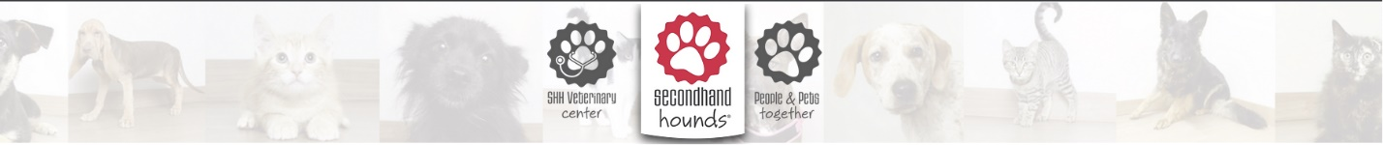

**Zahra Khan,**

**Vasudha Gulati,**

**Shalini Sarathy Komandur Chakravarthy**

Secondhand Hounds Intake Outcomes Calculator

**MIS 6060 Advanced Databases**

Professor Vijayan SUgumaran

**MIS 6060 Advanced Databases**

Secondhand Hounds Intake/Outcomes Calculator

# OVERVIEW

# General Description of the Organization

* **Secondhand Hounds** is a nonprofit animal rescue organization in Minnesota founded in July of 2009.The organization provides safe shelter, proper veterinary care, and daily necessities for animals at risk, while working hard to find each a permanent, loving home.
* Their key business operations include **fostering, veterinary services, animal rescue** and **animal rehabilitation**

**Problem Scenario**

* US Rescues and animal shelters generally submit their intake and outcome data to **Shelter Animal Counts**, A US national shelter intake/outcomes repository that aims to measure the progress in animal welfare, inspire life-saving collaboration and have a positive impact over pet homelessness. The information collected by Shelter animal counts can also help facilitate grant applications for Secondhand hounds.
* In their current state of operations SHH manually calculates their monthly intakes and outcomes by consolidating data from various sources and uploads them to the Shelter animal counts website. The process is labor intensive, costly and can only be conducted by specific resources with good understanding of the unstructured data.

**Data Sources**

* Secondhand hounds currently store their animal data in **Rescue Groups**, an animal welfare organization. Animal Intake and Outcomes information is also maintained in RG as part of the animal data.
* The current aggregated intake and outcomes count is calculated using their internal *admissions transport animal log*. These logs are separated by species i.e., canines and felines and are maintained in google sheets by the organization.

**Problems Solved**

|  |  |
| --- | --- |
| **Managerial Decision-Making problems** | **How does our Solution help?** |
| Multiple data sources used to pull data all having different formats and standards | * Provided a centralized structure which acts a one-stop shop for data * Cleaned and transformed incoming RG data to create consistency |
| Absence of dashboards and reports for KPI generation, current performance is measured manually and causes overhead | * Generated powerful performance insights * Provided a consolidated view of relevant data to facilitate decision making |

**Requirements for the DW/BI application**

* Initial client requirements and scope was provided by Secondhand Hounds in a word doc file
* Additional Wishlist items/requirements were also shared during our weekly meetings with the Program director Carrie as we progressed through development and implementation

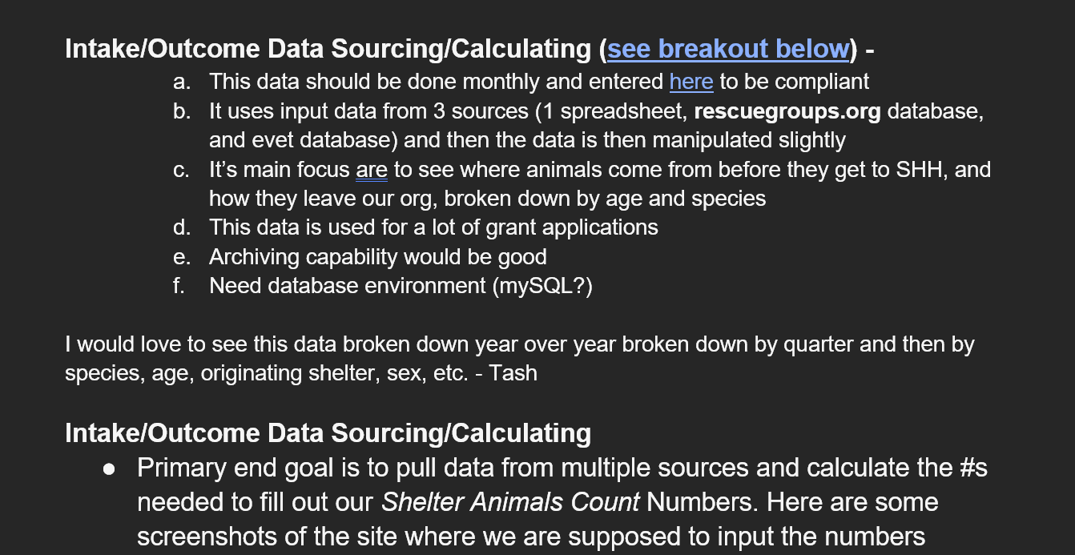

*Figure 1 Extract of Client Requirements File*

*Primary Requirements:*

1. *Develop a monthly intake and outcomes report by species and categories to be uploaded into Shelter Animals Count website*
2. *Develop a dashboard to summarize the numbers of animal’s intake, the numbers in rescue currently, and the numbers adopted will help show current workload for those working to care for and process these animals*

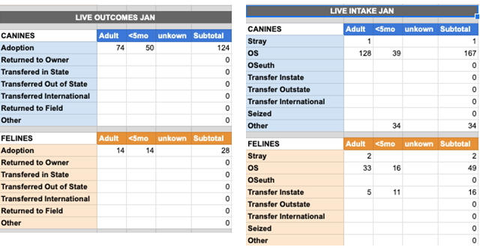

*Figure 2 Primary Requirement - Animal Intakes/Outcomes by Category*

*Figure 3 Shelter Animal Counts Website*

*Figure 4 Sample Intake Outcome Template provided by SHH*

*Additional Requirements:*

1. *Additional performance metrics requested:*
   1. *Animals Rescued, broken down by:*
      1. *% under 1 year, 1-3 years old, 3-6, 6-9, 9+*
      2. *% by size, broken into <15 lb., 15-35, 35-50, 50-70, 70+*
   2. *Adoption Fees collected for any given time (YTD,MTD,QTD and YOY)*
   3. *Measured current year performance against defined yearly SHH targets for adoption fees and animal intakes*
2. *Applied the following exclusions/ business rules:*
   1. *Days in Foster – Flagged animals that have been in foster care for > 1000 days*
   2. *Identified and flagged animals with unspecified size and age groups*

**Schema Design of the DW Application**

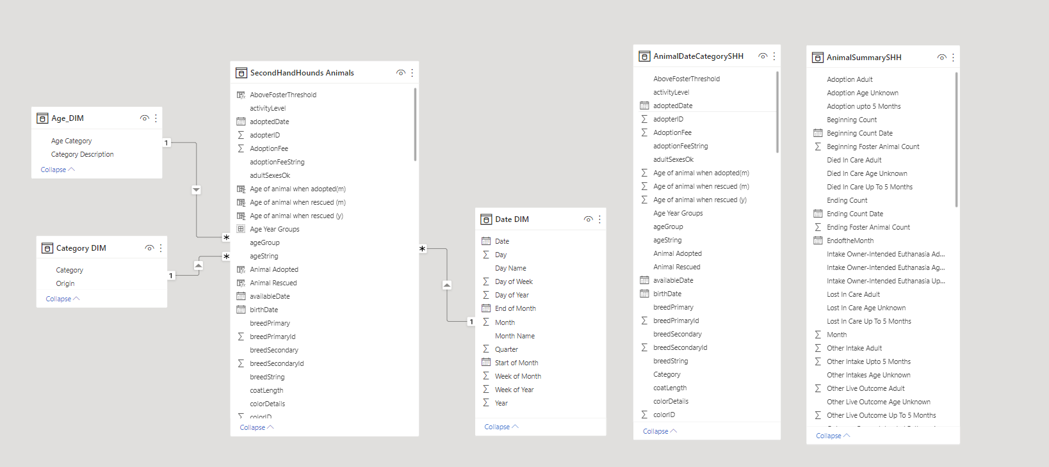

Figure 4 Schema Design

**Design Details**

To fulfill the requirements, we selectively imported the main Animals table from Rescue Groups. The animals table had all the necessary attributes for us to produce the intake/outcomes report deliverable.

We worked with Carrie to understand the origin attribute in the Animals table. To counter the unstructured and inconsistent nature of this attribute we developed 5 basic categories to map to animal origins. Carrie provided us with a file containing each category assignment based on its incoming origin. We used this information to develop an external Origin- Category mapping table

To facilitate intake and outcomes reporting we introduced additional dimensions like date, age groups, species and categories to calculate animal counts across multiple dimensions/measures

**Tables Created**

***Dimension Tables***

* Age Dim - Dim Table containing Animal Age Groups (i.e. Adult, Baby etc.)
* Category Dim - Dim Table containing Animal Category and Animal Origins mapping (i.e. OS, Stray, Transfer Instate, Transfer Outstate, Transfer International and Other)
* Date Dim - Dim Table containing various date dimensions (i.e. Year, Month, Quarter etc)

***Fact Table***

* Secondhand Hounds Animals - Core Animals table containing all necessary animal attributes imported from Rescue Groups
* Animal Date Category Secondhand Hounds - Combined intermediate Animal, Date and Category table *(leveraged for summarization)*

***Summary Tables***

* Animal Summary Secondhand Hounds - Summary table containing rolled up animal counts aggregated by Category and date

**Design Description and ETL**

***Data Warehouse Architecture Diagram***

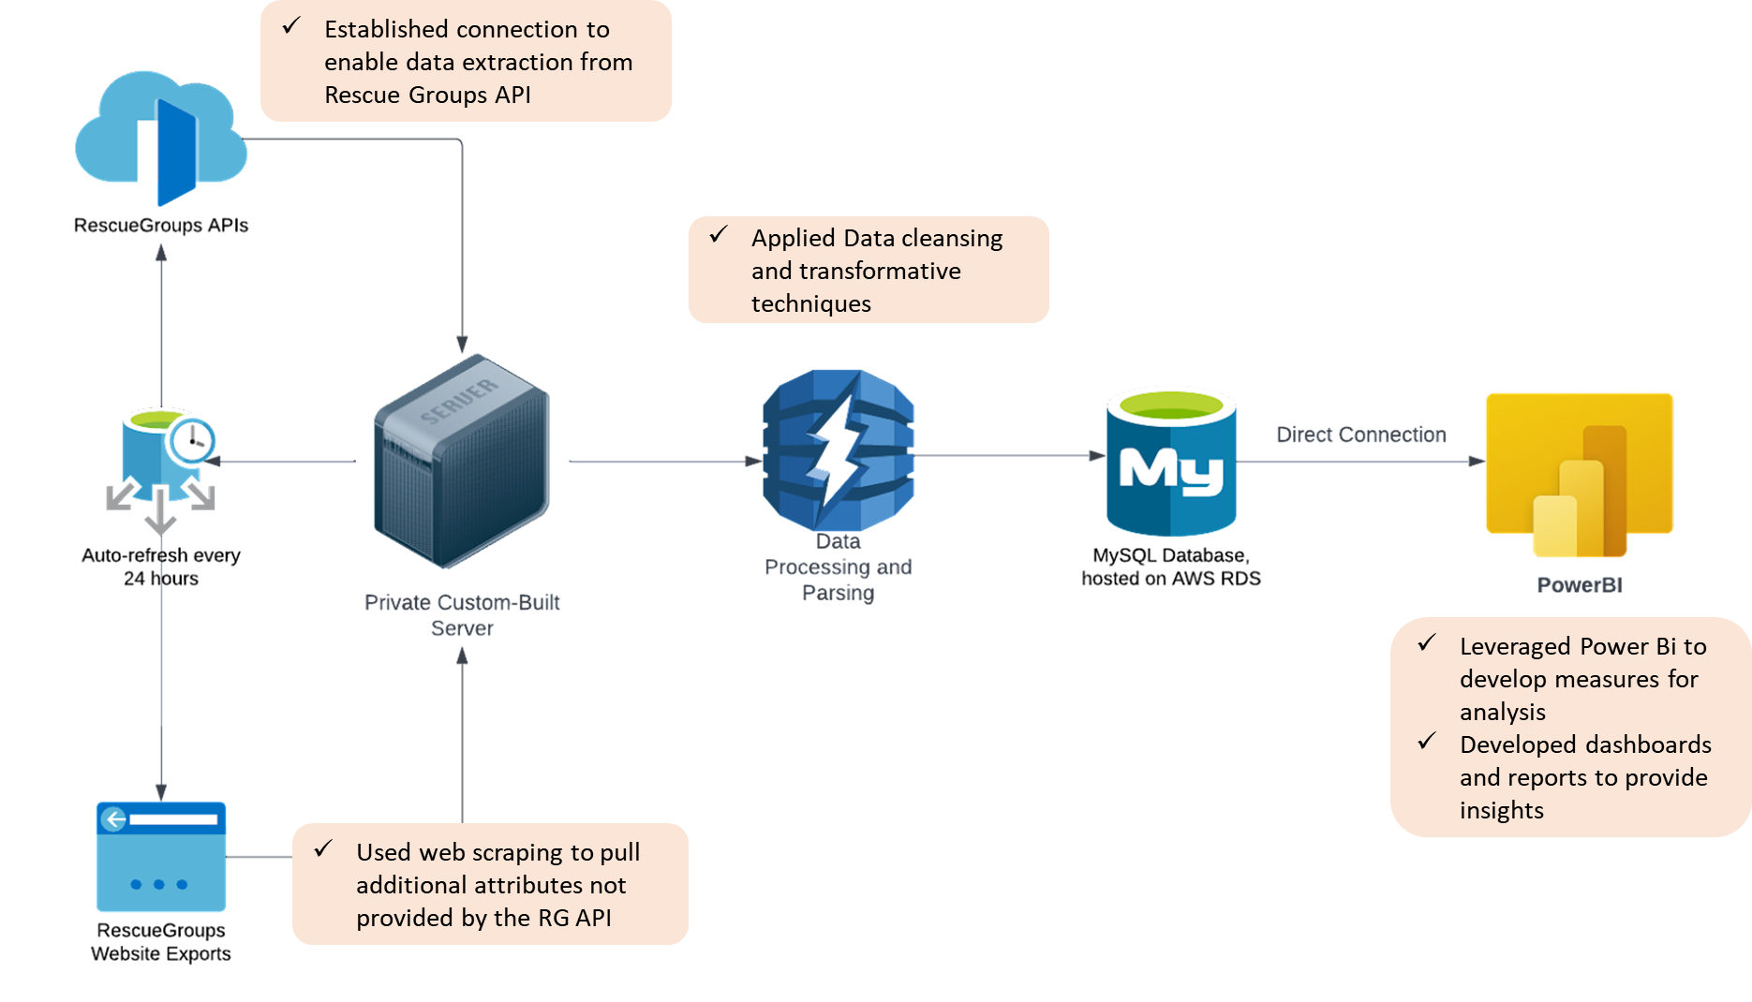

Figure 5 Data Architecture Diagram

**Table Calculations using DAX:**

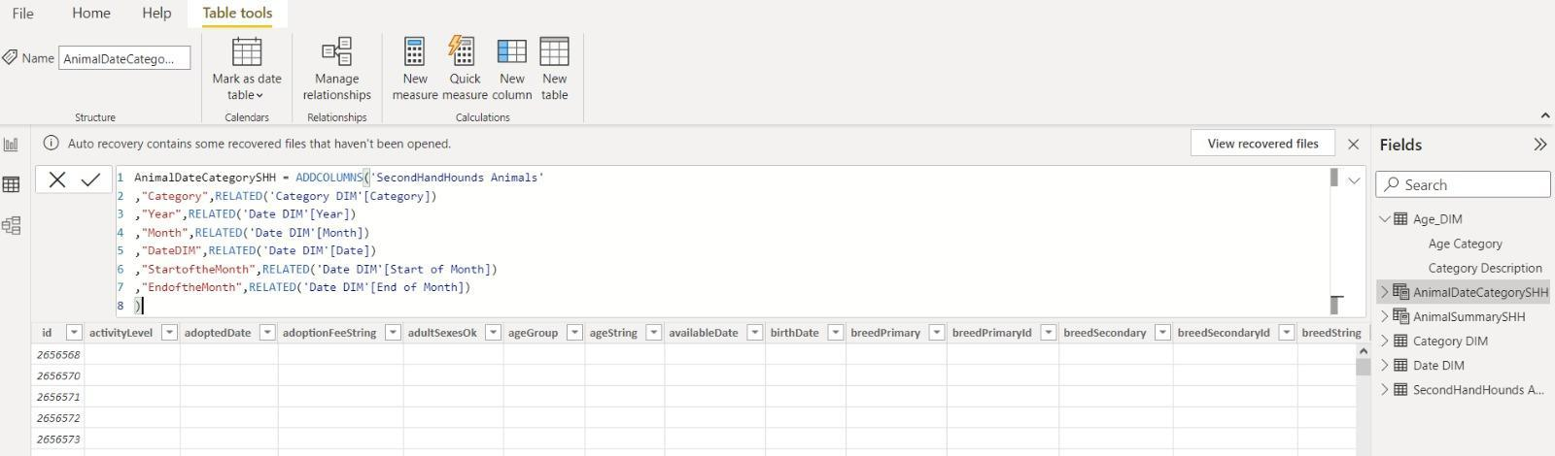

Figure 6 Combined/Joined Animal Date Category Table DAX

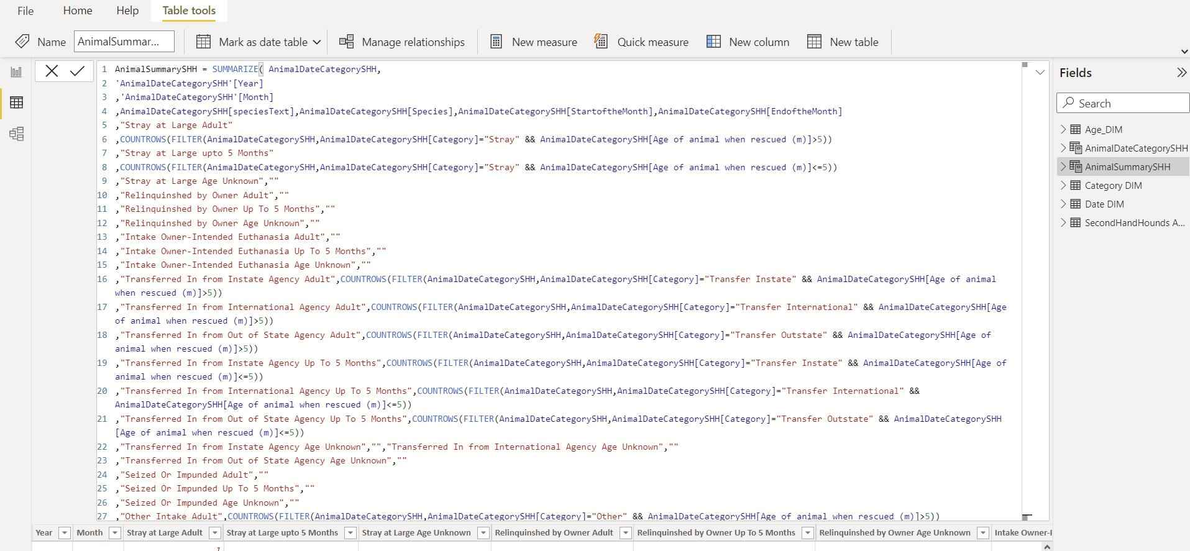

Figure 7 Animal Summary Table DAX code using PowerBI Summarize function

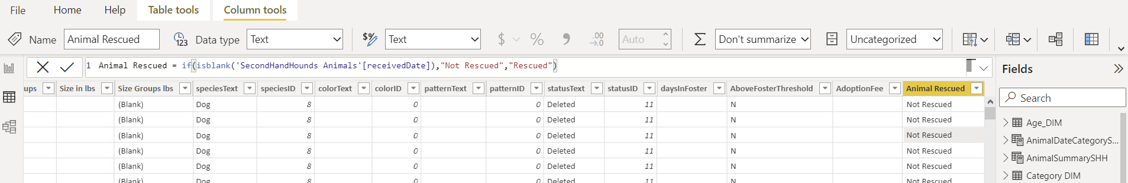

Figure 8 Animal Rescued Flag DAX

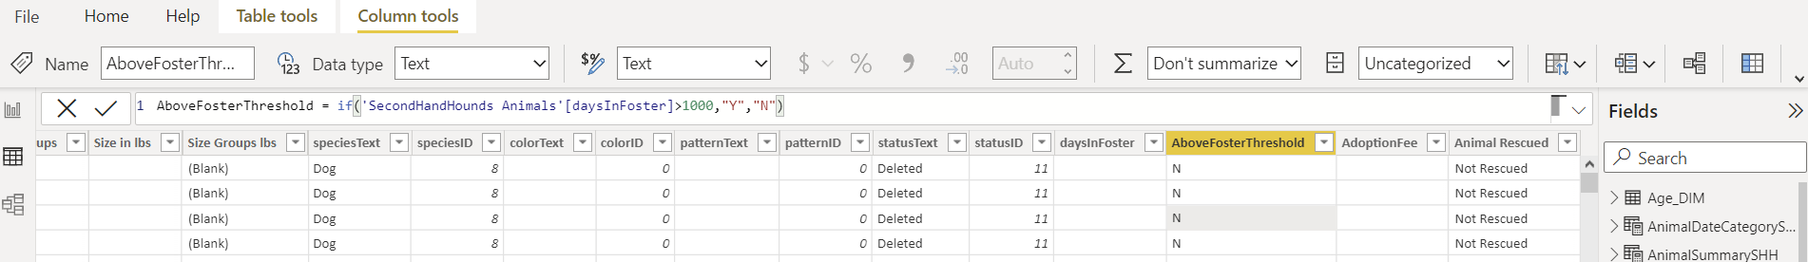

Figure 9 Foster Days 1000 days threshold Flag DAX

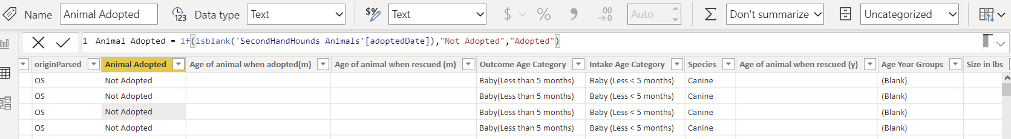

Figure 10 Animal Adopted Flag DAX

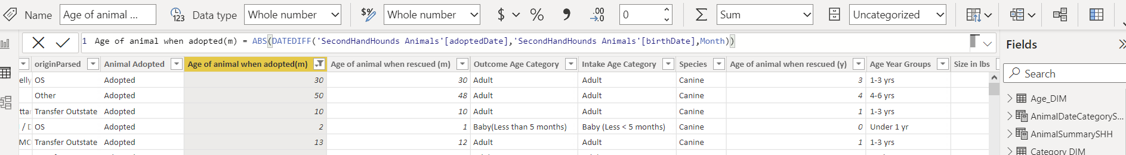

Figure 12 Animal Outcome Age (in months) DAX

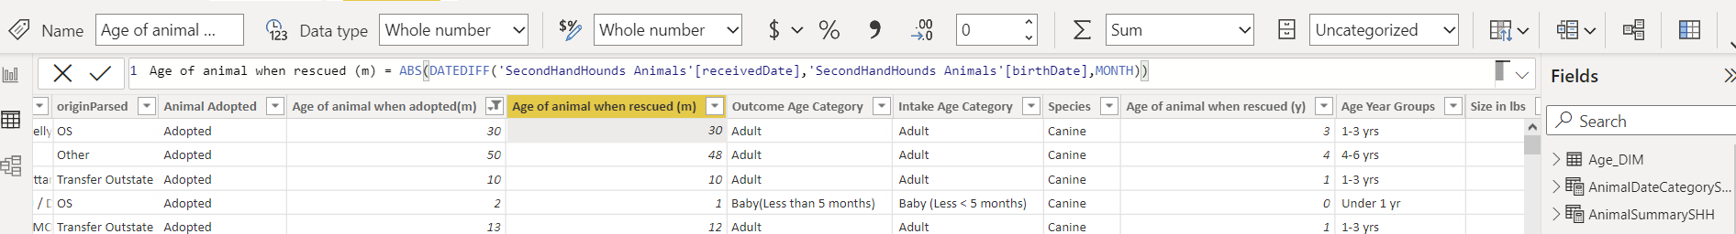

Figure 13 Animal Intake Age (in months) DAX

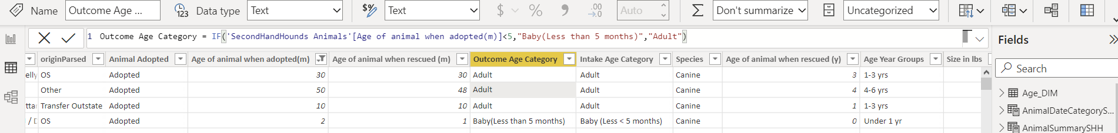

Figure 14 Outcome Age Category DAX

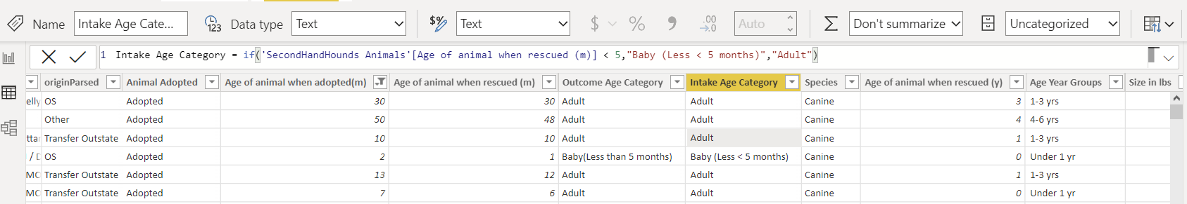

Figure 15 Intake Age Category DAX

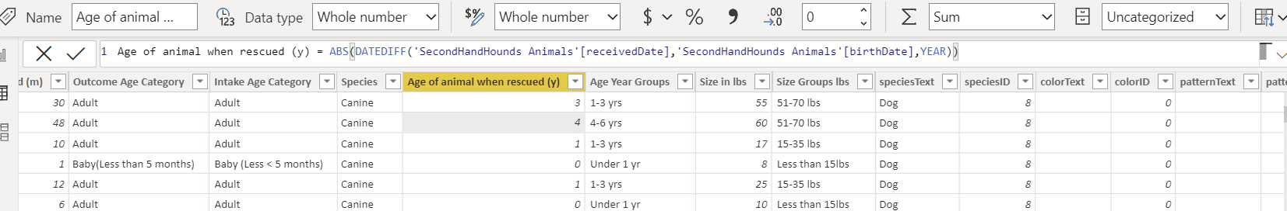

Figure 16 Animal Intake Age (in years) DAX

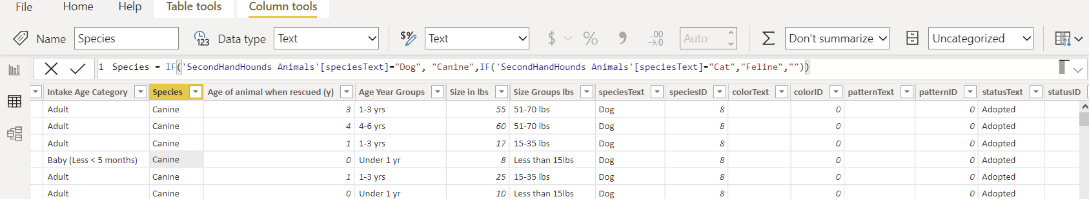

Figure 17 Species flag DAX

**Dashboards and Reports addressing managerial problems**

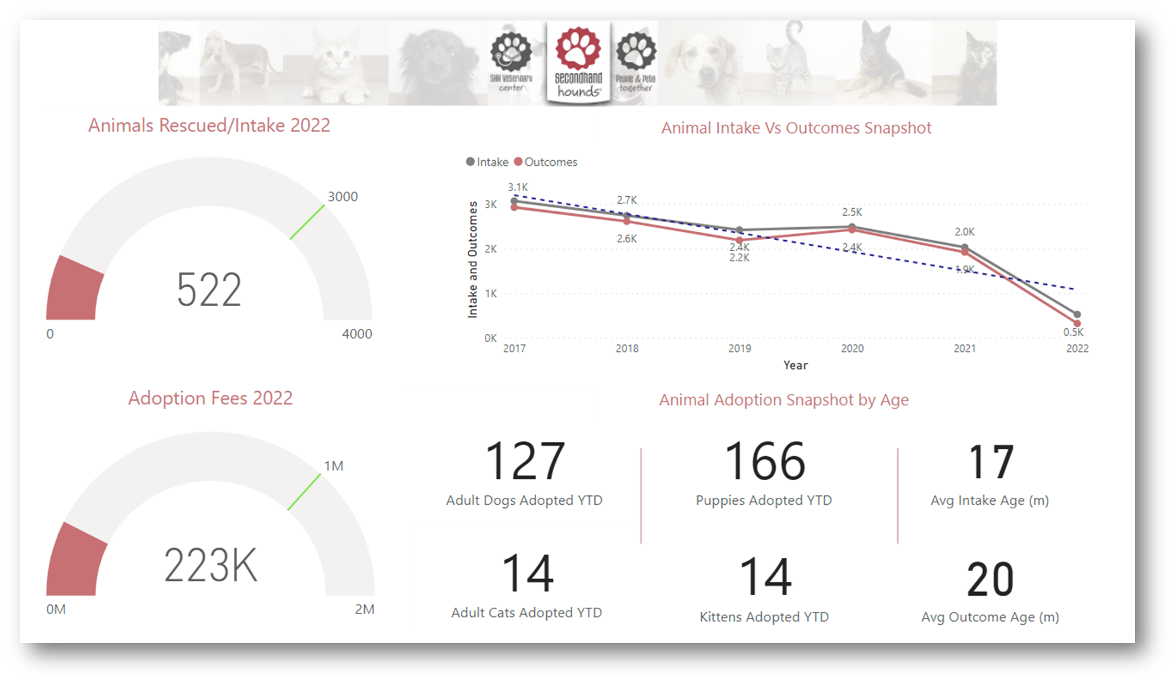

Figure 18 Current Year 2022 Performance Snapshot

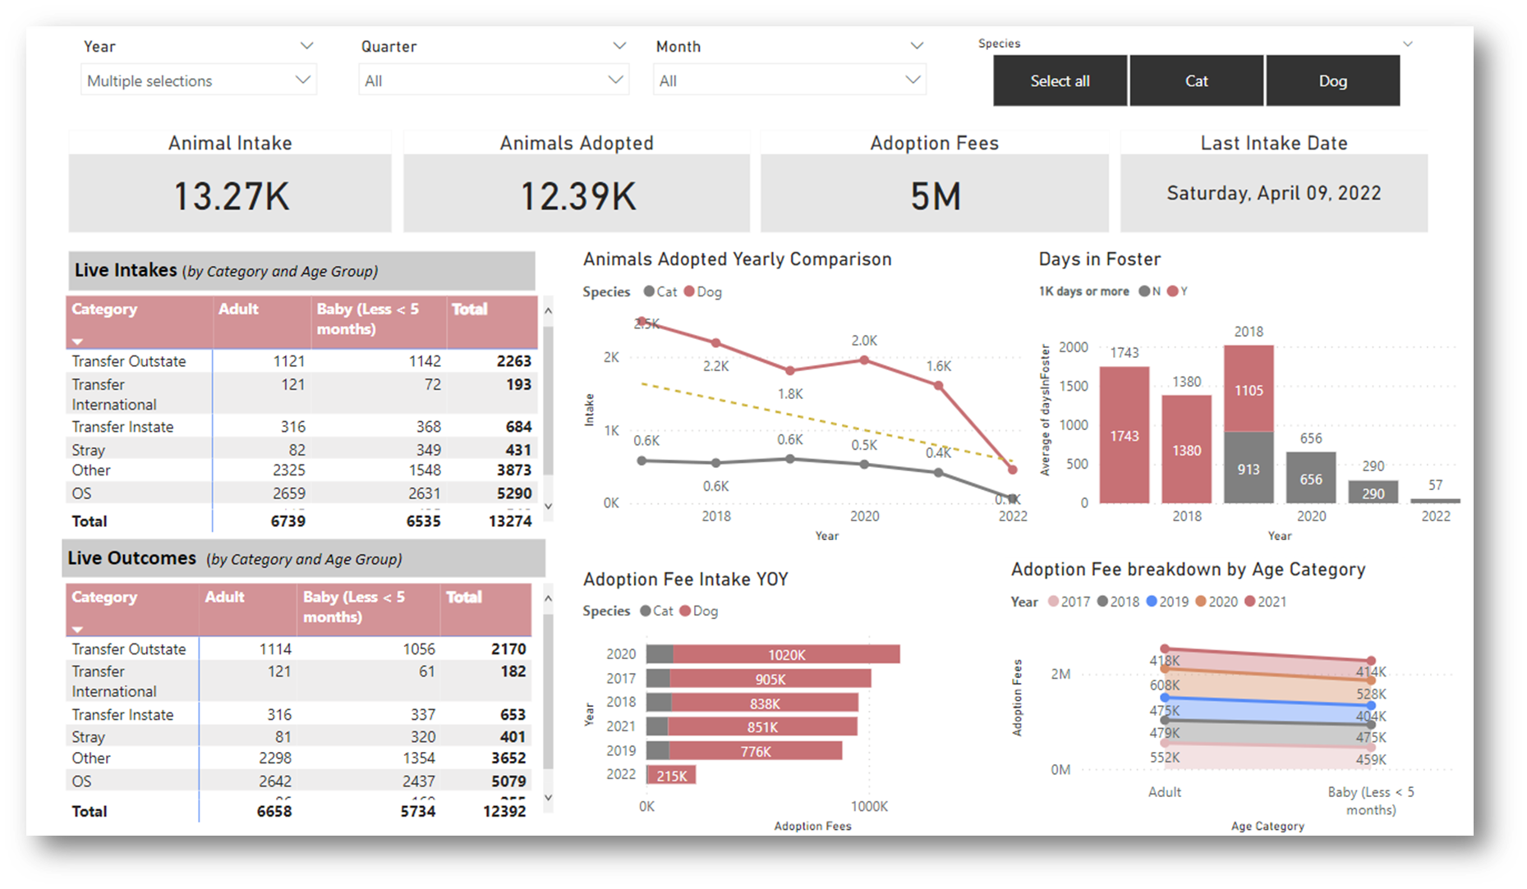

Figure 19 Performance Dashboard

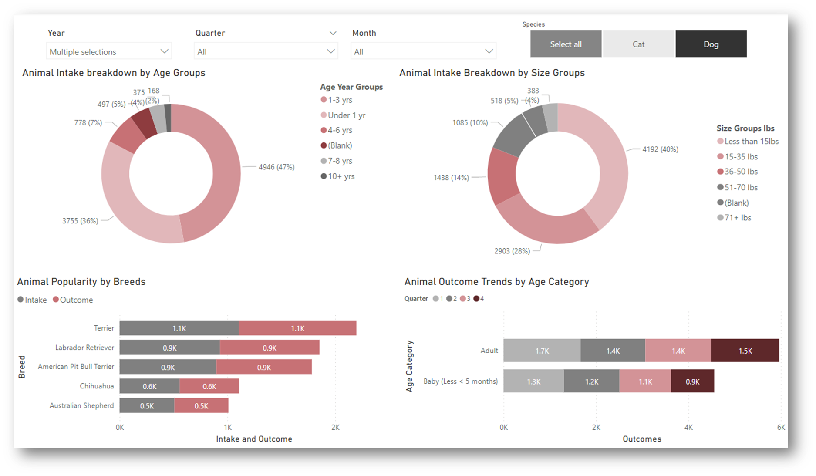

Figure 20 Animal Intake Dashboard

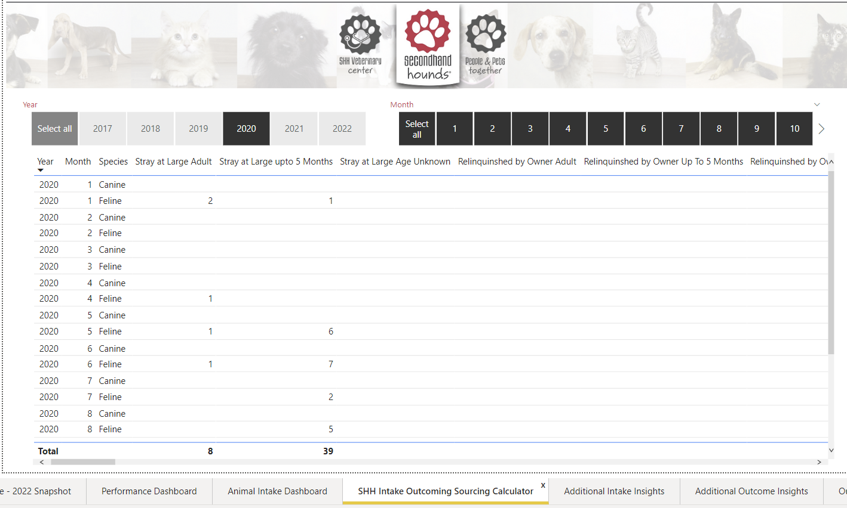

Figure 21 Intake/Outcome Sourcing Calculator Report

Figure 22 Animal Intake Decomposition Tree

Figure 23 Animal Outcomes Decomposition Tree

Figure 24 Animal Outcomes YOY Decomposition Tree

**Summary and Lessons learned**

It was our first experience working with a Non-Profit animal welfare organization. We had weekly calls with our clients at SHH which allowed us deeper insights into their business operations. This in turn enabled us to deliver dashboards and reports that best benefitted Secondhand Hounds.

**Technical Challenges:**

* Developed summary tables for sourcing the SHH Intake Outcome Calculator using DAX

**Data Quality Challenges:**

* Developed a workaround to handle data redundancies that existed in key attributes like Origin. An external mapping table was created to bucket all types of origins into 6 main categories
* Applied data transformative techniques to standardize attributes that contained mixed data-type values like Adoption Fees
* Applied logic to handle blanks in key deciding attributes either by assigning default values based on business rules or flagging these values to highlight discrepancies (i.e., foster days threshold > 1000 days, category default to OS in case of blanks)

**Special Instructions for Successful Testing**

Please note the following manual details steps that need to be followed to setup the connection and view the dashboard:

* [Secondhand Hounds Connection Setup Manual](https://docs.google.com/document/d/1ytNzQRXLNG3qZkB-f6PvLPj96gCWQDOjxSqQDmma7lU/edit?usp=sharing)